The EU Agency for Cybersecurity welcomes its new Executive Director: Mr. Juhan Lepassaar

ENISA not only celebrates the nomination of its new Executive Director, but also 15 years of successfully keeping Europe cyber secure. The Management Board of ENISA designated Mr. Juhan Lepassaar in July and he started his duties today.

Published on October 16, 2019

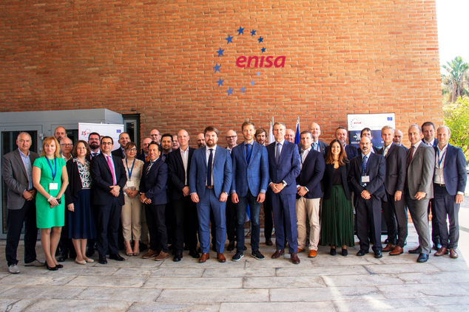

Tagged with

* [ENISA](https://www.enisa.europa.eu/search?Subject%3Alist=ENISA)
* [Management Board](https://www.enisa.europa.eu/search?Subject%3Alist=Management%20Board)
* [ENISA's Role](https://www.enisa.europa.eu/search?Subject%3Alist=ENISA%27s%20Role)
* [Executive Director](https://www.enisa.europa.eu/search?Subject%3Alist=Executive%20Director)
* [Executive Board](https://www.enisa.europa.eu/search?Subject%3Alist=Executive%20Board)
* [ENISA events](https://www.enisa.europa.eu/search?Subject%3Alist=ENISA%20events)

He will be leading the Agency, which has just achieved a permanent mandate within the provisions of the Cybersecurity Act (CSA) upgrading ENISA to a new phase of its history.

Mr. Juhan Lepassaar is a citizen of Estonia. Dedicated to the European Union, he has been a strong supporter of the development of the cybersecurity policy as Head of Cabinet of Andrus Ansip, Vice President for the Digital Single Market in the European Commission for the past 5 years.

It is within his previous function as Director for EU affairs at the Government Office of Estonia that Mr. Lepassaar had been initially given the chance to engage in cybersecurity policy.

On his first day at ENISA, **Mr. Lepassaar** expressed that “Cybersecurity permeates all sectors. The cybersecurity issues at stake are now widely recognised as crucial for Europe on the political level not just the technical level. Member States have come to agree on the need to increase cooperation and make joint efforts to develop a common approach meant to strengthen the European cyberspace.”

He expressed his vision for the Agency, stating “My vision for the Agency builds on two pillars, the NIS Directive* and the Cybersecurity Act. Developing further synergies, establishing and elaborating activities including making the certification proposal not only a reality but a success, increasing the opinions ENISA provides on NIS areas, growing the pool of competences for more targeted assistance, further cooperation within the NIS framework through dialogue via the CSIRTs network and cyber exercises and finally raising further awareness of cybersecurity and cyber hygiene.”

Over its lifespan, ENISA has increased its visibility and impact in Europe thanks to its expertise, notably in developing and supporting incident reporting, national cybersecurity strategies and exercises among others to keep the European cyberspace not only secured but also equipped to manage cyber-attacks or cyber crisis in the fastest and most effective ways.

With the CSA, the Agency has now acquired new responsibilities such as the Cybersecurity Certification Framework and an increased role in cyber crisis coordination and response, tools that address all aspects of the challenges ahead of us in securing the European Digital Single Market.